Project Design Phase-II

Data Flow Diagram & User Stories
Date | 6 September 2026
Team ID | Individual
Name | Namburi Sriya Ram
Project Name | Employee Raise Issue – Record Producer & Service Portal Integration
Maximum Marks | 4 Marks

Data Flow Diagrams:
The Data Flow Diagram shows how a software installation request moves through the ServiceNow system, from employee submission through approval and IT fulfillment.

DFD Level 0 – Software Installation Request Automation
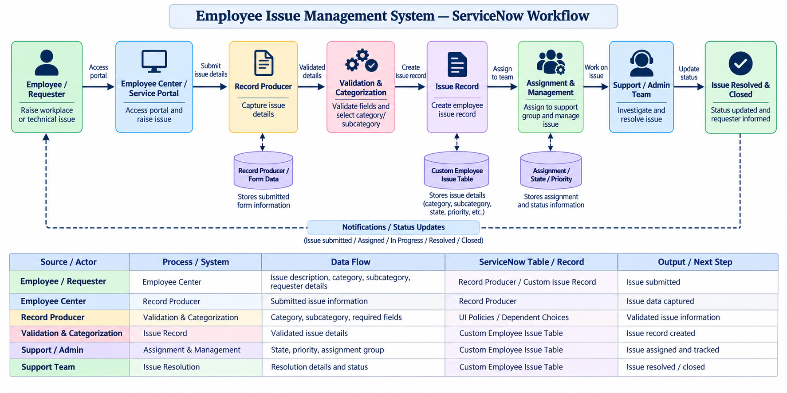

Data Flow Summary:

Employee → Employee Center → Record Producer → UI Policies & Dependent Choices → Custom Employee Issue Record → Assignment / Issue Management → Support Team Resolution → Issue Resolved & Closed

User Stories

The following user stories define the functional requirements for the Employee Issue Management System project.
User Type | Functional Requirement (Epic) | User Story Number | User Story / Task | Acceptance Criteria | Priority | Release
Employee (Requestor) | Issue Submission | USN-1 | As an employee, I can access the Employee Center and raise a workplace or technical issue. | The employee can access the issue submission option and successfully open the issue form. | High | Sprint-1
Employee (Requestor) | Issue Submission | USN-2 | As an employee, I can provide the required issue details such as category, subcategory and description. | Required fields are completed and the issue can be submitted successfully. | High | Sprint-1
Employee (Requester) | Issue Categorization | USN-3 | As an employee, I can select an appropriate category and subcategory for my issue. | Relevant subcategories are displayed based on the selected category and the selected values are stored correctly. | High | Sprint-1
System / ServiceNow | Data Validation | USN-4 | As the system, I can validate the information entered by the employee using UI Policies and required fields. | Mandatory fields are enforced and inappropriate or incomplete submissions are prevented. | High | Sprint-1
System / ServiceNow | Record Creation | USN-5 | As the system, I can create an employee issue record from the submitted information. | A unique issue record is created containing the requester, category, subcategory, description and other required details. | High | Sprint-1
Support / Admin | Issue Management | USN-6 | As a support/admin user, I can assign an issue to the appropriate support group. | The issue can be assigned to the appropriate group and the assignment information is saved successfully. | High | Sprint-2
Employee (Requestor) | Request Tracking | USN-7 | As an employee, I can track the status of my submitted issue. | The employee can view the current status of the submitted issue, such as New, In Progress, Resolved or Closed. | Medium | Sprint-2
Employee (Requestor) | Notifications | USN-8 | As an employee, I can receive updates about important changes to my issue. | The employee receives relevant status or resolution updates when applicable. | Medium | Sprint-2

